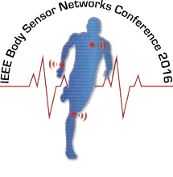
Greetings Potential Participant!
Proposal Template
In order to effectively evaluate proposals all responses are required to follow the challenge proposal template. Illustrations are permitted however there is a hard limit of 2 pages maximum on submissions.
Overview of Proposal (150 words)
Our app will display everything in a single persistent graphic. This will ensure that whatever a responder needs it will be available to them…somewhere.
Pedigree (50 words)
Person 1: Sr. in Electrical Engineering at State University working in Dr. Brain’s Lab
Person 2: volunteer policeman, self-taught in Java and C++
Experience and Examples (100 words)
Participated in Global Game Jam 2015, wrote a web client for Dogspotting, 2015 AIGA “Cased” Semi-Finalist, etc.
Backing agencies and resources (50 words)
A single Altair 8800 and endless patience, Tiny Indi Dev Co., senior design group
Details and Design Philosophy (250 words)
Our design approach for this challenge is to generate an extensive and byzantine menuing system that encompasses every possible bit and statistic. We also think that gamification is key, so accelerometers will be used to trigger sound effects whenever a responder takes a step.
Why this challenge aligns with your interests (100 words)
I’m the son of a firefighter and I want to make her job safer. I want to bring a new aesthetic and modern design to traditional roles.

Figure 1. Example placeholder

